|  |  |
| --- | --- |
| Assessment Title | Identify protocols |

## Competency Details

|  |  |
| --- | --- |
| Unit code/s and title/s | ICTICT443 Work Collaboratively in the ICT industry |
| Qualification code/s and title/s | ICT40120 - Certificate IV in Information Technology (Release 3) |
| Business unit/Work group | Business and Arts/IT Studies |

## Instructions

|  |  |
| --- | --- |
| Method/s of assessment | Questioning (Written)  Product (Create) |
| Overview of assessment | This assessment will require you to answer questions and the answer to these questions will aid in the development of a report. |
| Task/s to be assessed | This assessment will require you to complete the following tasks   * Task 1: Identify Requirements * Task 2: Identify Protocols * Task 3: Review Protocols * Task 4: Developing Report part A * Task 5: Improve Protocols * Task 6: Developing Report part B |
| Time allowed | Refer to your schedule for submission dates. |
| Location of assessment | Assessment can be completed anywhere with access to the resources required (see Resources Required section below) |
| Decision making rules | To receive a satisfactory outcome for this assessment you must complete all parts correctly.  Word counts are provided as guidance only. |
| Assessment conditions | This assessment must be demonstrated in a workplace or simulated environment where the conditions are typical of those in a working environment in this industry.  This is unsupervised assessment and you may access any required resources.  This is not group work and must be completed as an individual. |
| Resources required | To complete this assessment, you will require the following:   * Access to Learn with Internet access * Learn resources * Word processing software such as Microsoft Word. * ICTICT443 - ASDS - ACME Trading Services Documents.zip * ICTICT443 - ASDS - ACME Trading Services Template * Regulations and Standards’.zip folder. |
| Result notification and reassessment information | You will be provided feedback and the result for your assignment on TAFESA Learn. You will be and given the chance to resubmit with required corrections only once.  Refer to the TAFE SA assessment policy for more information <https://www.tafesa.edu.au/apply-enrol/before-starting/student-policies/assessment> |

**Background information**

Acme Trading Service is a small traditional in-office tech consulting business of nine staff located at 123 Norwood Parade, Norwood.

Acme Trading Services main business tasks are to help their clients use technology better by:

* Improving the business processes that take place
* Reducing the costs of the company
* Maximising any tech opportunities

Acme Trading Service help businesses in developing and implementing technology to accelerate business growth, manage risk better, reduce cost, and help change how the business system is functioning.

Due to the current climate, the business will need to shift their work practices from their traditional in-office operation to a work-from-home environment.

Having employees work from home highlighted the urgent need for Acme Trading Services to change the way they were operating. They had to find better ways to get the same tasks completed, re-establish effective communication systems and of course there was the issue of cybersecurity.

This move from a secure and safe office space to a home office comes with many challenges and security issues Acme Trading Services are not familiar with.

**Scenario**

Acme Trading Services has hired ITWorks to prepare the move from their traditional in-office operation to a work-from-home environment.

You are an employee of ITWorks in the Business Analysts team and you have received an email from Acme Trading Services.

**Task 1 – Identify Requirements**

ITWorks have received the following email from Acme Trading Services:

Subject: Team shift in operations to Work from Home (WFH) environment

Hi ITWorks

ACME Trading Services would like your expertise and assistance in the following matter.

ACME Trading Services is small traditional in-office tech consulting business located at 123 Norwood Parade, Norwood. Due to the current climate, our staff are needing to shift our operations to a work-from-home environment.

We would like for you to assess our current team protocols and provide advice to enable staff to complete this move safely and securely.

If there are any other issues/work practice changes you see in completing this move, providing us with this information would be much appreciated.

Can you create a report with staff requirements and protocols as guidelines for staff to be able to work from home?

Kind Regards

Acme Trading Services Manager

Peter Smith

1.1

Acme Trading Services has not provided enough information in the initial email for you to create the report. You are to email Acme Trading Services to clarify the requirements and to obtain further information enabling you to complete the report.

You require further information on the following:

a) Communication tools and technology available to support virtual, remote, and collocated teams

b) Current policy and guidelines on using collaborative tools

c) Staff hardware and software access list

d) Staff roles and responsibilities

e) Team Protocols for virtual ways of working including Cyber Security Protocols

Your email must be written in a professional format.

**Do not send this email!**

Place your email screen capture here:

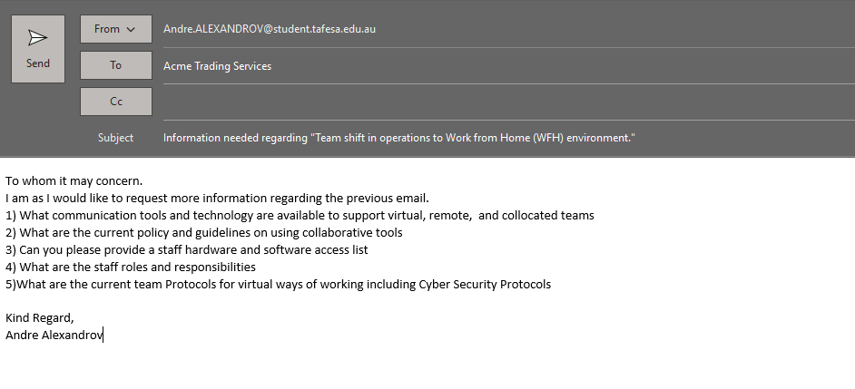

**Task 2 – Identify and Review protocols**

ACME Trading Services has sent through the following documentations:

* ACME Trading Services Policy and Procedures Manual
* ACME Trading Services Tools and Technology

**2.1**

View the ACME Trading Services Policy and Procedures Manual.

**a)**

Identify and name the two ‘Team Communication Protocols’ for virtual ways of working and list them in the space below.

1) Passed information on through emails rather than discussing issues over the phone.

2) Understand the purpose of the collaboration tool

**b)**

Identify ACME Trading Services current Cyber Safety Protocol and summarise the purpose of this protocol below:

Answer:

Providing guidelines for how to keep workplace data and sensitive information private and secure from Cyber Safety Threats

**c)**

* List two roles and three responsibilities of staff team members for working in a collaborative environment according to the ‘ACME Trading Services Policy and Procedures Manual’?

Role: Working with a group of people sharing ideas and skills in order to achieve a common goal.

Answer: Working collaboratively, instead of individual.

Responsibilities:

1) communicate clearly,

2) actively listening to others,

3) respecting the diversity of your colleagues.

**d)**

List two roles and three responsibilities of Management in **promoting** collaborative work environments?

Roles: Bringing staff together and making sure they own all of the business goals

Answer: Providing clarity and context for team members

Responsibility:

1) Cultivate openness and transparency

2) Establish a judgement-free idea-sharing culture

3) Encourage collaboration across departments

**Task 3 – Review technology**

Review the ‘ACME Trading Services tools and technology’ document. From your understanding of this document:

**3.1**

Identify and list two communication tools and one technology ACME Trading Services have available to support teams working collaboratively in virtual environments.

Communication tools

1) Microsoft Teams

2) Zoom

Technology

1) Email

Frequency of use: Emails should be sent as a communication tool technology and used when needed for work purposes.

Virtual platforms should be used to address action items, roadblocks, and questions for the upcoming

weeks or barriers from last week. It is recommended to have:

• Weekly team meetings

Regular meetings help team members progress with their weekly work.

The following meetings can be called at any time:

• Emergency meetings

**Task 4 - Developing Report part A**

You are to start developing the report as requested by ACME Trading Services.

Open the ‘ACME Trading Services Report template’ document and add your **name and student ID** to the **title page of this report.**

Save this document as **‘ACME Trading Services Report**’

**Complete the ‘Current Business Environment’ section:**

* **Part A) Identify and Review protocols** with the information from **Task 2.1 a), b), c) and Task 3.1** above.

Headings have been created for you in this report.

**Task 5 - Improve protocols**

Determining areas to improve ACME Trading Services team protocols for working collaboratively in a virtual environment.

* View the documents found in the ‘Regulations and Standards’.zip folder.

**5.1**

Legislation, codes, regulations and standards, and work health and safety requirements for collaborative work arrangements.

**a)**

View the **‘Fair Work Act 2009’.**pdf

* Look at Part 1-1 Division 2.

What is the ‘Object of this Act’ (approx. 30-word count)

**Answer:**

**b)**

View Chapter 2 – Terms and conditions of employment

* Part 2-2 The National Employment Standards
* Look for **Division 2 —The National Employment Standards**

Under the ‘National Employment Standards’, what are the are 11 minimum employment entitlements that have to be provided to all employees?

a) Maximum weekly hours

b) Requests for flexible working arrangements

c) Offers and requests for casual conversion

d) Parental leave and related entitlements

e) Annual leave

f) Personal/carer’s leave, compassionate leave and unpaid family and domestic violence leave

g) Community service leave

h) Long service leave

i) Public holidays

j) Notice of termination and redundancy pay

k) Redundancy pay

View the ‘**Fair Work Regulations 2009**’.pdf.

Look at Part 1‑2—Definitions Ø Division 2 – The Dictionary Ø 1.07 Meaning of serious misconduct

Under **(3) For subregulation** (1),

What does ‘Conduct that is serious misconduct include’?

a) the employee, in the course of the employee’s employment, engaging in:

(i) theft; or

(ii) fraud; or

(iii) assault; or

(iv) sexual harassment;

b) the employee being intoxicated at work;

c) the employee refusing to carry out a lawful and reasonable instruction that

is consistent with the employee’s contract of employment.

**d)**

View the **‘Staff code of conduct’**.pdf document.

What does a staff code of conduct provide? (approx. 40-word count)

**Answer:**

The staff code of conduct provides the rules, values, ethical principles and vision for your business

**e)**

View the ‘**Safety legislation**.pdf document’

* Which Act provides for the safety, health and welfare of persons employed or engaged in industry in South Australia?

**Answer: Work Health and Safety Act 2012 (SA)**

* Together with this Act, which Regulation sets up health and safety duties to provide protections from hazards and risks in the workplace?

**Answer:**

Work Health and Safety Act 2012 (SA)

* What does the ‘Codes of Practice’ provide guidance to? (approx. 20-word count)

**Answer:** **provide guidance as to what measures should be taken by employers to prevent work**

**place injury**

**Task 6**

**6.1**

Identify which of the two documents ACME Trading Services had provided to ITWorks that lists the virtual platform tools used and the frequency these virtual platforms are used.

Document name:ACME Trading Services tools and technology

What are the Virtual platform tools used and the Frequency of use?

**Virtual Platform 1)** **Microsoft Teams**

Frequency of use: Weekly team meetings

**Virtual Platform 2)** **Zoom**

Frequency of use: Weekly team meetings

**Task 7 – Developing Report part B**

**Complete:**

* **Part B)** ‘**Improve current protocols’** with the information from **Task 5.1 and 6.1** above.

Headings have been created for you in this report

Assessment submission:

* Assessment 1 Identify Protocols document
* Acme Trading Services Report